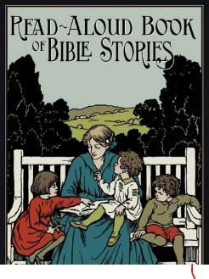
Some resources available from Formed.org
- Read-Aloud book of bible stories

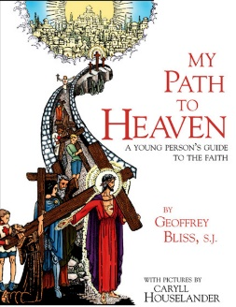
- My Path to Heaven

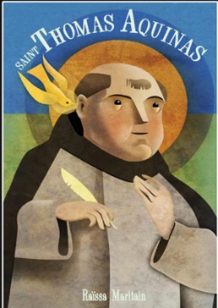
- Saint Thomas Aquinas

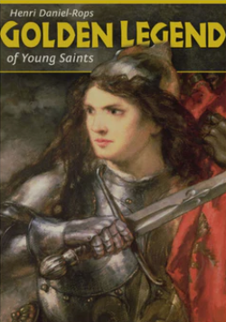
- Golden Legend of young saints

There are many other books, audio books, audio drama, and Movies for kids. Please check it out.
If you have an account before, just use your email to Sign In, and go to your email to click on a link that allow you to access.
If you have never had account, click on the Sign Up. Use our parish (Ascension Chinese Mission) to gain access. You will need to provide your email address.
Let me know if you have any issue.
Share your kids favorite books or movies to other parents so that they can show their kids, too.

